Greenville Little League
2017 Information

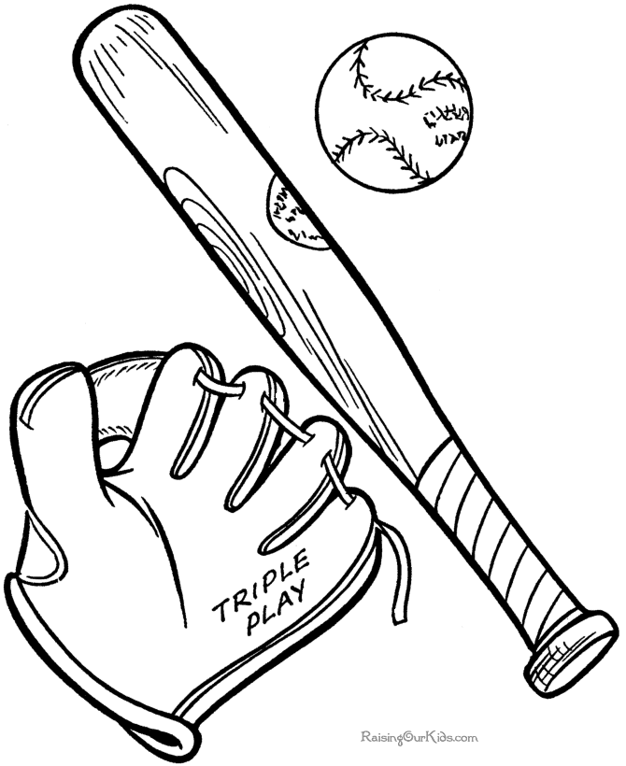
• “Like Us” on FACEBOOK to receive important updates and information – Search: Greenville Little League Association. Major announcements are posted on our Facebook page to reach the most people the quickest.

• Email – info@greenvillellbaseball.com
(don’t forget the ll between greenville and baseball)

• Website – www.greenvillellbaseball.com
(don’t forget the ll between greenville and baseball)

Mandatory Player Evaluations:
• Saturday March 25th (7-8 year olds) @ GHS football field 12-2 PM
(11-12 year olds) @ GHS football field 2-3:30 PM
(9-10 year olds) @ GHS football field 3:30 – 5 PM
***Rain Make-up Day is Sunday – Same times and location***
• Monday March 27th (Make-up - Any age Group) @ Hempfield Elementary
School Gym at 6 PM

T-Ball participants: will be contacted later in the spring. There are no player evaluations for T-Ball. T-Ball season generally starts in early JUNE. We need parents to help coach T-Ball teams…email us if you can help.

Field Work Days: Saturday April 1, 8, 15, 22 9AM – 12 PM…Adult help is greatly needed to get the fields / complex ready for the upcoming season. One day of help (9AM-12 Noon) will count as volunteering to get your $50 refund back.

Practices: Begin Week of April 1st on the fields (some teams may start prior at alternative sites).

Raffle Tickets: Raffle Ticket stubs due to your manager no later than Friday April 28th. Winners will be drawn opening day during the pre-game ceremonies. If you think you can sell more tickets please let us know!!

Opening Day – Saturday April 29th (Rain date Sunday April 30th)
• 8:30 AM – Players meet on Packard Field for Pictures
• 9:00 AM - Parade from Packard field to Little League Complex
• 9:30 AM Pregame Ceremonies
• 11 AM Games Begin

**All volunteer coaches need to fill out the volunteer clearance forms. So contact us via email ASAP if you plan on applying to help coach.

