Greenville Little League
2017 Registration Opportunities

The Greenville Little League would like to invite you to sign up for the upcoming 2017 Greenville Little League Season. Come join the fun!
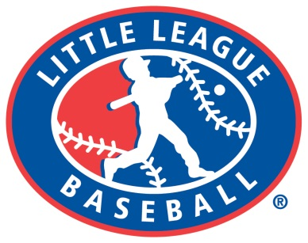
Divisions and Typical Ages :
T-Ball – ages 4-6
Minors (Coach Pitch) – ages 7-8
Mid Minors (Kid Pitch) – ages 9-10
Majors – ages 11-12
Junior League – ages 13-14
Sr. League – ages 15-16

Registration Dates / Locations:
• Sunday February 12th (5 PM – 7 PM) @ Family Video
• Wednesday February 15th (5 PM – 7 PM) @ Fresh Grounds Coffeehouse
• Thursday February 16th (5 PM – 7 PM) @ Fresh Grounds Coffeehouse

Registration Fees:
- Player Fee ($40 T-ball, $50 ages 7-16, $75 for family (2 or more siblings)).

- $50 Volunteerism Fee (this will be returned to you immediately after working the concession stand one evening, helping with field work one Saturday or volunteering to umpire one game).

- $25 Fundraiser Tickets …Each family is asked to sell 5 raffle tickets to help offset league costs. All you are doing is paying the $25 ahead of time. When you eventually sell the tickets you keep the money and turn just the tickets into the league for the drawing on opening day.

What to Bring:
• Copy of the child’s birth certificate that we can keep.
• Registration form / Med. Release form (both available at sign ups as well)
• You may bring a separate check or money order for the $50 volunteerism fee that will not be cashed and will be returned to you for volunteering. Only the checks of those who did not provide volunteer service will be cashed / deposited by the Little League.

****THERE IS NO ONLINE REGISTRATION THIS YEAR****.
Any forms / registration fees can be mailed to Greenville Little League PO Box 544 Greenville PA 16125. They must be post marked no later than March 1, 2017 to guarantee registration. Questions? Contact us at info@greenvillellbaseball.com

